SUBMITTED BY PRIYA

# IBM ASSIGNMENT-2

TEAM ID : PNT2022TMID17666 NAME : PRIYA

REG NO : 611619205039

Build a python code. Assume u get temperatureand humidityvalues(generatedwithrandomfunctiontoavariable)and writeaconditiontocontinuouslydetectalarmincaseofhightemper ature.

# program:

importrandomtemp=random.randint(0,100

)humid=random.randint(0,100)print("Note: ")print("NormalTemperatureLevel is 50°C") print ("Normal HumidityLevelis50%")

print(" ")

if(temp>=50):

print ("Temperature is High",temp,"°C")else:

print ("Temperature is Normal",temp,"°C") if(humid>=50):

print ("Humidity is High",humid,"%")else:

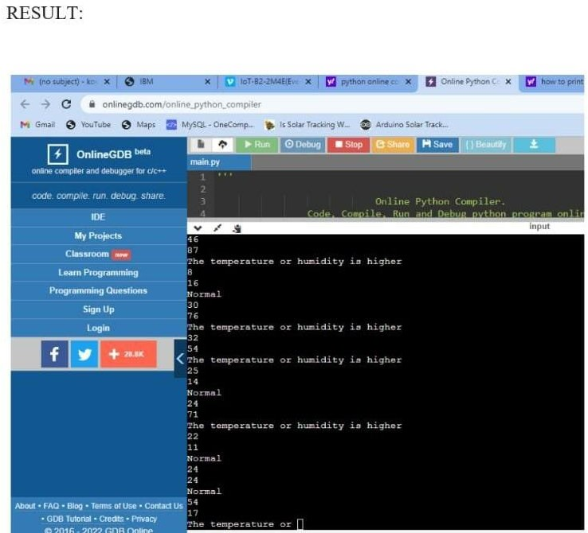

print("HumidityisNormal",humid,"%")